Project Design Phase-II Data Flow Diagram & User Stories

|  |  |
| --- | --- |
| Date | 21 October 2022 |
| Team ID | PNT2022TMID34387 |
| Project Name | Retail Store Stock Inventory Analytics |
| Maximum Marks | 4 Marks |

# Data Flow Diagram:

A Data Flow Diagram (DFD) is a traditional visual representation of the information flows within a system. A neat and clear DFD can depict the right amount of the system requirement graphically. It shows how data enters and leaves the system, what changes the information, and where data is stored.

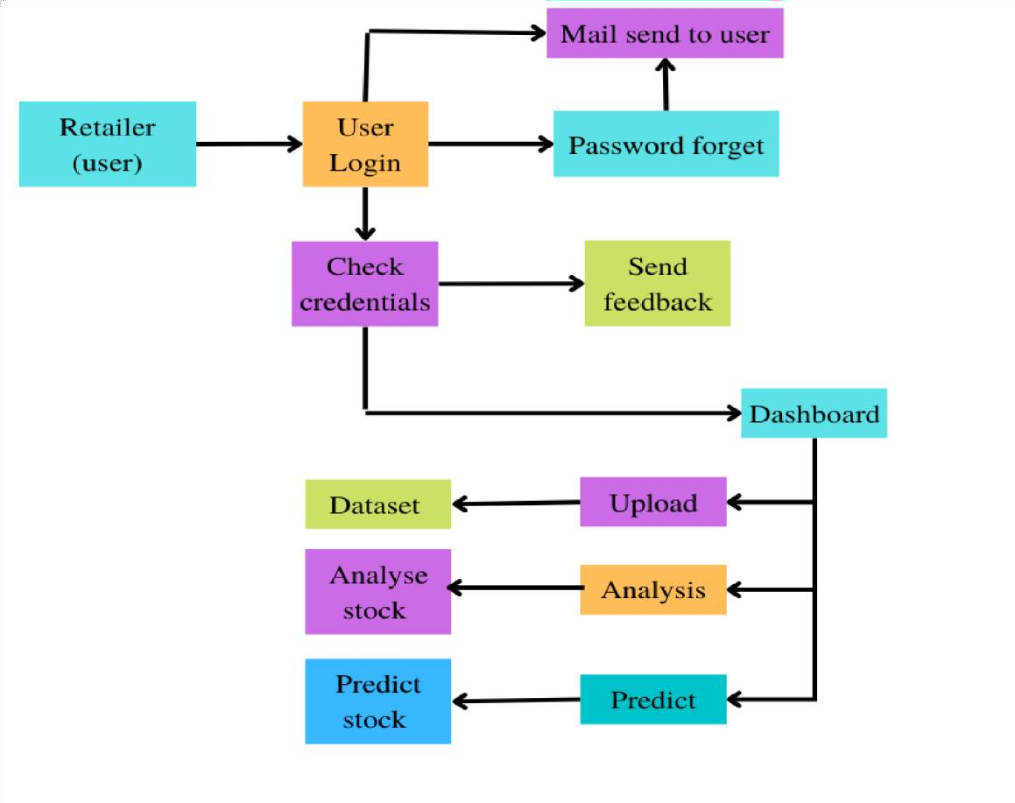

# User Stories :

|  |  |  |  |  |  |  |
| --- | --- | --- | --- | --- | --- | --- |
| **User Type** | **Functional Requirement (Epic)** | **User Story Number** | **User Story / Task** | **Acceptance criteria** | **Priority** | **Release** |
| Customer (Mobile user) | Registration | USN-1 | As a user, I can register for the web application by entering my email, password, and confirming my password. | I can access my account / dashboard | High | Sprint-1 |
|  |  | USN-2 | As a user, after completing the registration I will receive confirmation email once I have registered for the web application | I can receive confirmation email & click confirm | High | Sprint-1 |
|  |  | USN-3 | As a user, I can register for the web application through LinkedIn | I can register & access the dashboard with  LinkedIn Login | Low | Sprint-2 |
|  |  | USN-4 | As a user, I can register for the web application through Google account | I can register & access the dashboard with  Gmail login | Medium | Sprint-1 |
|  | Login | USN-5 | As a user, I can log into the application by entering email & password after installing the web application | I can access the dashboard by login into the application | High | Sprint-1 |
|  | Dashboard | USN-6 | As a user, I can view the charts and graphs representation of the dataset and the information shown in the dashboard | I can analyse the stocks in my retail store. | High | Sprint-1 |
| Customer (Web user) |  | USN-1 | As a user, I can register for the web application entering my email, password,confirming my password. | I can access my account / dashboard | High | Sprint-1 |

|  |  |  |  |  |  |  |
| --- | --- | --- | --- | --- | --- | --- |
| Customer Care Executive |  | USN-2 | As a user, after completing the registration I will receive confirmation email once I have registered for the web application | I can receive confirmation email & click confirm | High | Sprint-1 |

|  |  |  |  |  |  |  |
| --- | --- | --- | --- | --- | --- | --- |
| **User Type** | **Functional Requirement (Epic)** | **User Story Number** | **User Story / Task** | **Acceptance criteria** | **Priority** | **Release** |
| Administrator |  | USN-3 | As a user, I can register for the web application through LinkedIn | I can register & access the dashboard with LinkedIn Login | Low | Sprint-2 |
|  |  | USN-4 | As a user, I can register for the web application through Google account | I can register & access the dashboard with  Gmail login | Medium | Sprint-1 |
|  | Login | USN-5 | As a user, I can log into the web application  by entering email & password after installing the application. | I can access the  dashboard by login into the application | High | Sprint-1 |
|  | Dashboard | USN-6 | As a user, I can view the charts and graphs representation of the dataset and the information shown in the dashboard. | I can analyse the stocks in my retail store. | High | Sprint-1 |
| Customer Care Executive |  | CCE-1 | As a customer care executive, I will always be available for the interaction with the  customer to clarify the queries. | An executive will analyse the customer complaints,  rectify their problems | High | Sprint-2 |
| Administrator |  | ADMIN-1 | As an administrator, I will manage backup and recovery, data modelling and design, distributed computing, database system, and a data security | Administrator can evaluate, design, review and implementing a data,they are also responsible for updating and maintaining the  data. | High | Sprint-2 |